**Portfolio Project Option 2**

Lance I. Evans

Colorado State University Global

CSC515-1: Foundations of Computer Vision

Dr. Brian Holbert

4 December 2022

**Summary**

The initial challenge that was present in this experiment related to the sizing of the images. Whether they were too large or too small, the image was not able to be effectively used. To overcome this challenge, we set parameters around the size of the image, if the sum of the height and width were smaller than or larger than 2000, they were increased or decreased by 50 percent until they were , respectively. The next challenge was managing the appropriate scale factor, minimum neighbor, and minimum size for the faces. This was overcome through trial and error. We started off with the first image, in an attempt to perfect the adjusted formula for that one. While adjusting those parameters the first to adjust was the scale factor, due the pseudo faces that were being detected. The scale factor determines how much the image size is reduced each time the scale attempts to locate a face (Ranu, 2020). We then adjusted the minimum neighbors to determine how many blocks needed to be similar for it to be considered a face (2020). The final adjustment for this challenge was the minimum size, the initial selection worked well for the first image, then wasn’t able to detect the smaller faces that we wanted in the later images. Detecting the eyes required only a few adjustments once we were able to detect all the faces. The same parameter types were used and adjusted when attempting to recognize all eyes in the photographs. The eyes were originally wrapped in a rectangle just as the faces are, and once the eyes were accurately depicted, we removed the rectangle feature to only blur the locations of the eyes.

Each of these images performed quite well once the algorithm was fine tuned. However, the photo with several people detected one face twice and detected a face on a shirt location. This was a one off, that recognized enough difference in the “face” that it could be classified as a face. The image with a non-human subject was able to accurately depict a human face versus a non-human subject. Although, when some of the parameters were adjusted, one of the non-human subjects found a face on a nose, and occasionally was not able to pickup the actual face, possibly due to excessive makeup used in the photograph. The image with human subjects far away from the foreground was able to accurately detect the faces closeup, while leaving the other subjects unchanged. All but one of the photographs incorporated a relatively complex background and did fairly well in each of the instances. In an attempt to make the program operate more accurately we added the flags CASCADE_DO_CANNY_PRUNING and CASCADE_SCALE_IMAGE, but this yielded no further improvement after everything had been adjusted. Below are the results of my program.

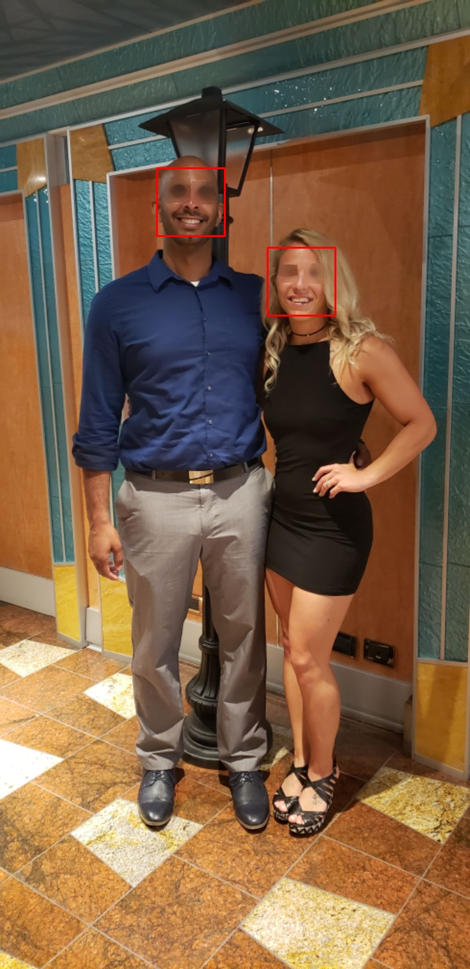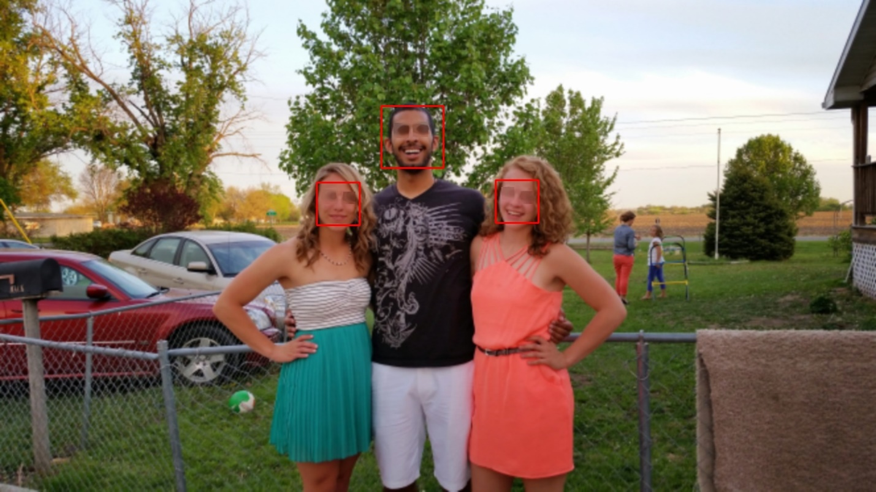

**References**

Ranu, R. (2020, September 22). *Terminologies used in face detection with haar cascade classifier: Open CV*. Medium. Retrieved December 4, 2022, from https://ai.plainenglish.io/terminologies-used-in-face-detection-with-haar-cascade-classifier-open-cv-6346c5c926c